Create Node-RED Service

Aim:

To create a web application creates a Node-RED service.

Steps followed:

* Navigated to the App creation page

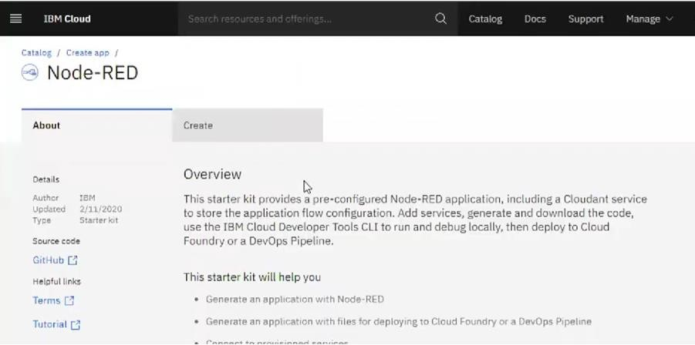

* + Entered project details and clicked on create

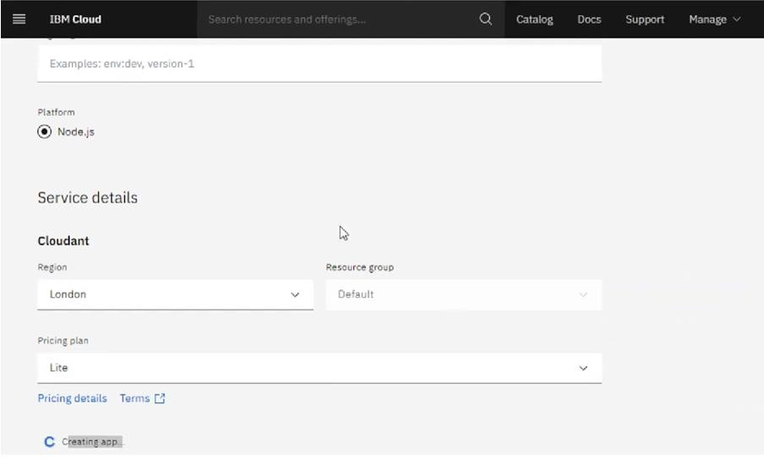

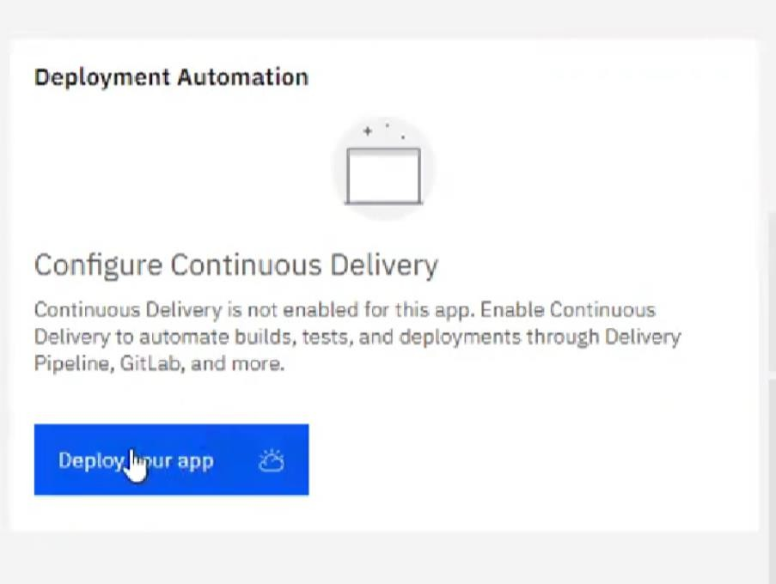

* Setting up the environment and deploying the app

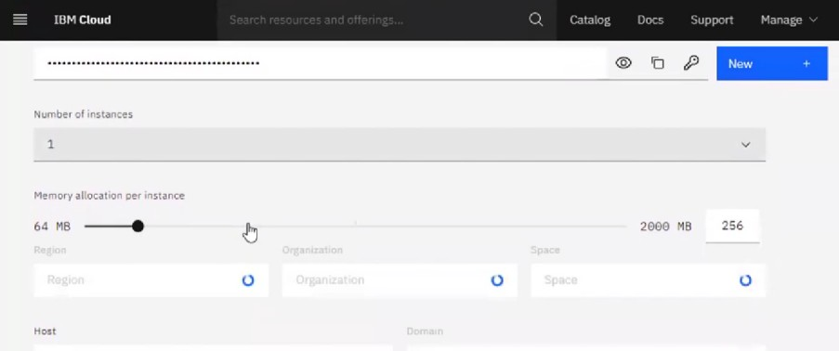

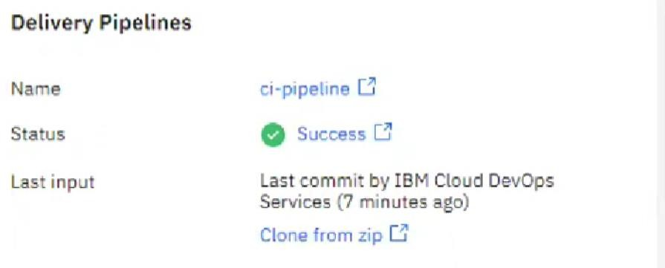

* Dragged and dropped components into the editor

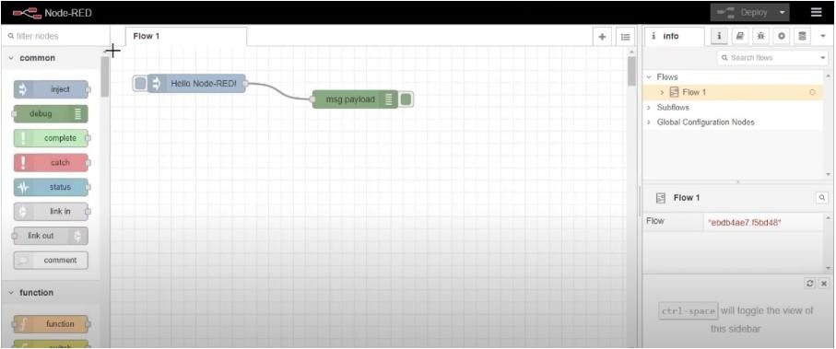

* Editing some values of the properties

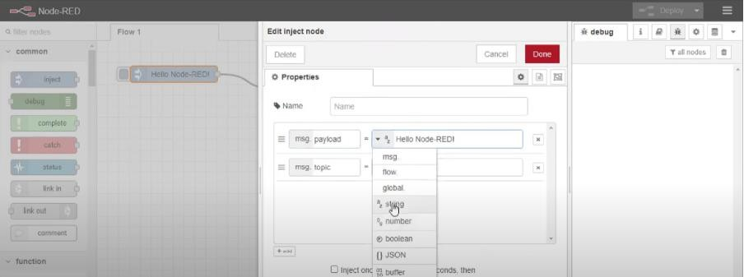

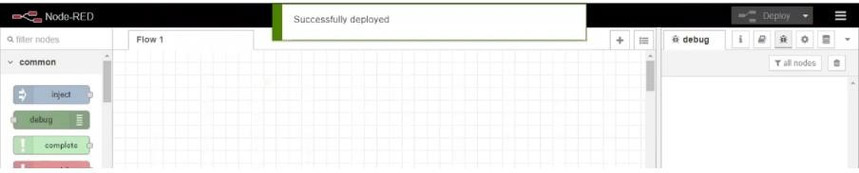

**Result: Successfully created a NodeRED service on IBM Cloud**